# **Monthly Meeting #1**7**:** TA **Meeting**

| **Meeting Date:** | Nov 2, 2023 6:15 PM | |
| --- | --- | --- |
| Meeting Time: | 6:15 PM ET | |
| Meeting Location: | Virtual | |
| Meeting Type: | AI Studio TA Meeting | |
| Student Team Members: *(check box if in attendance)* | * Rachel * Vanessa * Kashish * Pamela * Elena * Nyah | |
| Other Attendees:  *(e.g., Challenge Advisor, TA)* | TA - Keith | |

Pre-Work:  
 Creating own custom object detector

* <https://medium.com/swlh/creating-your-own-custom-object-detector-using-transfer-learning-f26918697889>

NuScenes -> XML example??

* [mobile_robotics/nuscenes extract and write out 2d full annotation boxes.ipynb at master · asvath/mobile_robotics (github.com)](https://github.com/asvath/mobile_robotics/blob/master/nuscenes%20extract%20and%20write%20out%202d%20full%20annotation%20boxes.ipynb)

# MEETING AGENDA

1. Catching Keith up with what we have done so far
   1. PIcking our Object Detector based on time, accuracy
      1. Assessed best confidence score per every model, (**we didn’t plot these differences**)
         1. May want to consider finding a way to visually present how we chose the architecture in the slide deck for our Final Presentation
   2. We are approved for HPC cluster
      1. Vanessa and Pam should have access through Tufts
      2. We have ~500 GB
   3. Next steps:
      1. Converting to XML
      2. Transfer Learning with TensorFlow
         1. Needs XML for TF Records
      3. Hoping to be done with modeling in the next 2 weeks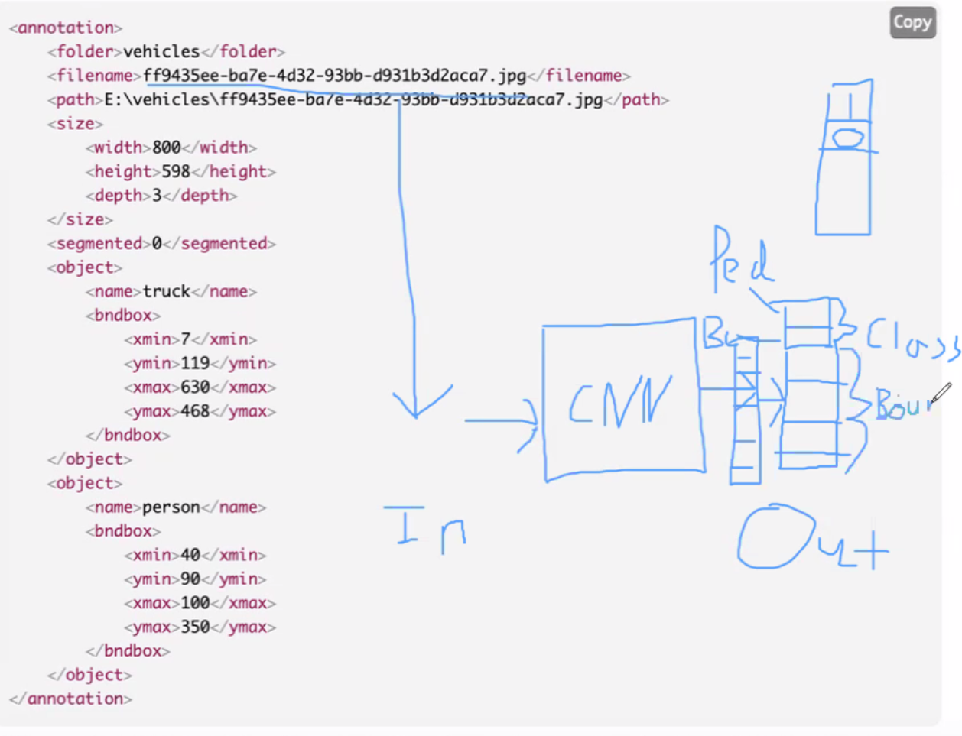
2. Transfer Learning Visual
   1. What is our input and output?
      1. Input: Image
      2. CNN
      3. Output: Layer
         1. Vector (with categories)
         2. One-hot-encoding [1,0,..] for categories
   2. Feed-forward network on top of RCNN
      1. During transfer learning, take faster-RCNN output as intermediate layer, and pass onto our output layer
   3. One loss function: class
   4. Other loss function: bounding box
3. Code sample:
   1. Modify existing model for transfer learning:  
       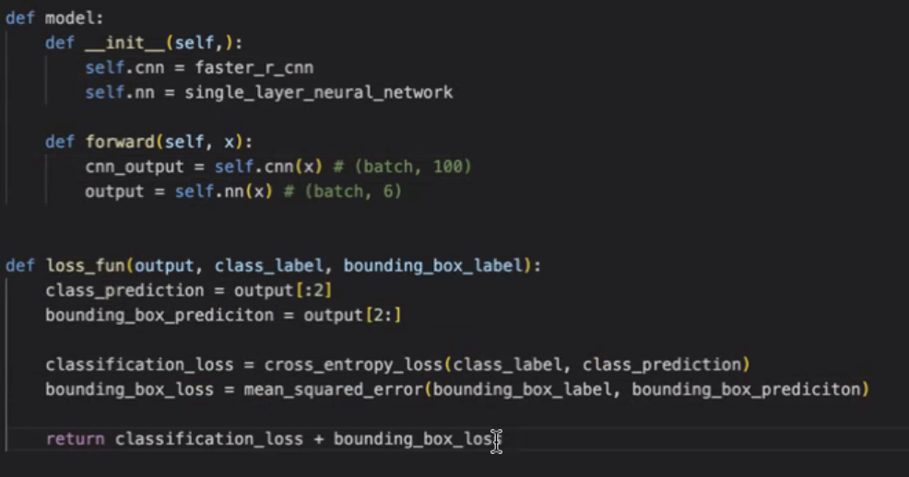

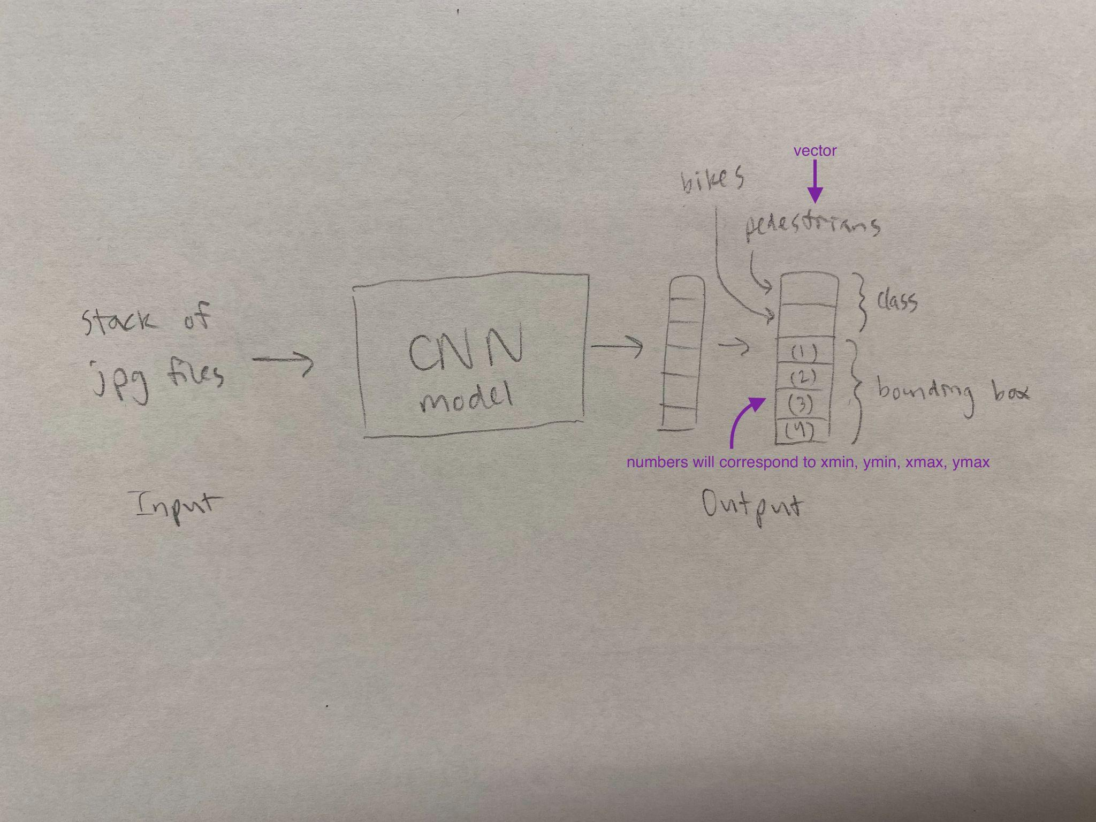

(Potentially incorrect reinterpretation of Keith’s CNN diagram)

* Think about how we balance the classes
  + For example, the dataset has way more human.pedestrian,adults, than it does vehicle.bicycle
    - So Keith suggests we can consider ways to play with balance (i.e. only deal with construction workers)
* Data Loader
  + New object class
    - Take new images and xml files in different folders
    - Image loader can load into training pipeline
  + Building training pipeline
    - Specify loss function, objective function so we can train the model
* Xml, csv, and similar file types = purpose is to structure metadata in a way that makes sense
* Final presentation
  + Will be anytime between Mon dec 4 - fri dec 8, we’ll work to schedule a time that works for everyone
  + Will be 30 min
  + Can be virtual or in-person, but keith is inclined to host it virtually bc we’re located far apart
  + Keith hasn’t heard from maria about presentation at MathWorks

3 python scripts:

Image

Model

Training Pipeline

Xml file -> vector (contain class label and bounding box label)

Notes:

[Read and Write Pascal Voc XML Annotations in Python - ML Hive](https://mlhive.com/2022/02/read-and-write-pascal-voc-xml-annotations-in-python)

[nuImages data format](https://www.nuscenes.org/nuimages#data-format)

<https://www.geeksforgeeks.org/xml-parsing-python/>

# 

# ACTION ITEMS

| **Task/Assignment** | **Team Member** | **Deadline** |
| --- | --- | --- |
| Research on how to convert to XML |  |  |
| consider finding a way to visually present how we chose the architecture in the final presentation slide deck |  |  |
| Think about how we balance the classes between pedestrians and bicycles |  |  |
|  |  |  |